**Java**

Table of Contents

• Compilation steps of java program: 3

• ClassLoaders: There are 3 types of classloaders. 3

• Class: 4

• Java access specifiers: 5

• Nested classes: 6

• String: 6

• Varargs: Variable-Length Arguments 7

• Interface: 7

• Lambda expression and Stream 8

• Exceptions: 11

• Try with resources: 12

• Multithreading: 13

• Double check singleton: 15

• Callable and Future 17

• Fork/Join Framework 18

• Transient: 19

• Native: 19

• Reflection: 19

• Memory management: 23

• Garbage Collection: 24

• Reference types: 25

• Clone() 27

• Comparable 27

• Iterable: 27

• Collections 28

• Timer and TimerTask: 30

• Serialization 31

• Netwroking 32

• Remote Method Invocation (RMI) 33

• LDAP 33

• Java Bean 35

* **Compilation steps of java program:**

1. Compile java code with **javac** which will produce **bytecode** (.class files).
2. Bytecode is executed by Java Virtual Machine (JVM) which is part of Java Runtime Environment (JRE). Bytecode is platform independent, so in each OS there are OS specific JVM which can run the same bytecode.

For running bytecode JVM compiles classes using Just In Time compiler (JIT), each class is compiled only once. Java class files loaded into heap memory by Classloaders.

* **ClassLoaders**: There are 3 types of classloaders.

1. **BootStrap ClassLoader**: it is a Machine code that loads the first pure Java ClassLoader. It is loading classes from rt.jar location. (standard java classes)
2. **Extension ClassLoader**: is a child of Bootstrap and loads the extensions of core java classes from the JDK Extension library (jre/lib/ext)
3. **System/Application Classloader**: it loads the application type classes found in the environment variable CLASSPATH, -classpath (for example classes implemented by us). It is a child of Extension

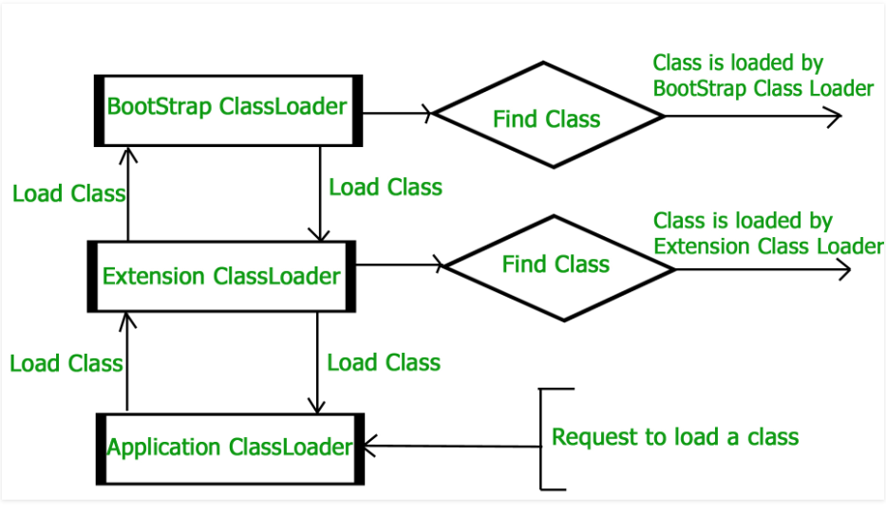

System.*out*.println(ArrayList.class.getClassLoader());  
System.*out*.println(LocalClass.class.getClassLoader());

Output:  
null -  **Boostrap**

[jdk.internal.loader.ClassLoaders$AppClassLoader@512ddf17](mailto:jdk.internal.loader.ClassLoaders$AppClassLoader@512ddf17) – **System**

* **Class:**

class foo {  
 // static block  
 static {  
 System.*out*.println("static block");  
 }  
  
 // instance initialization block  
 {  
 System.*out*.println("instance initialization block");  
 }  
  
 foo() {  
 System.*out*.println("constructor");  
 }  
}

**static block**: is called during startup. Used for initializing static variables

**instance initialization block**: is called before each constructor call.

If the parent class have default constructor, before executing each constructor of a child class, will be called the default constructor of parent class.

If parent class doesn’t have default constructor, the first line of child’s constructor should be called the parent’s constructor (e.g. super(1);).

All classes by default extends from **Object** class.

Object class have the following functions:

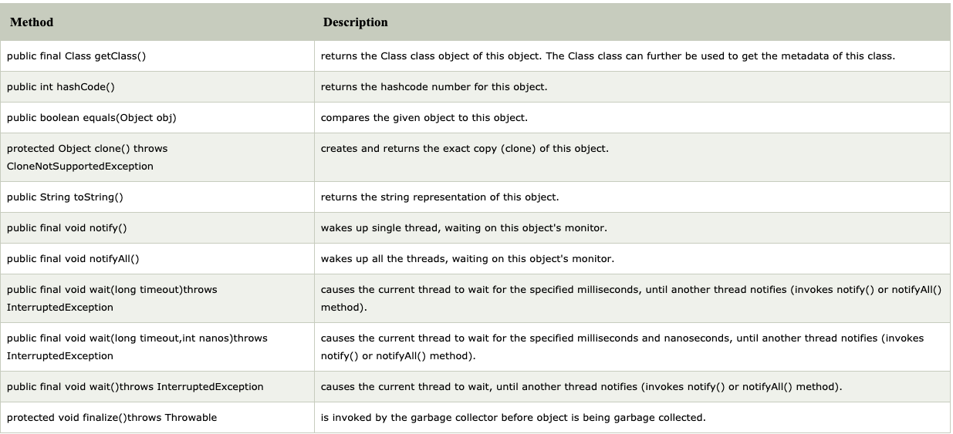

Java child class doesn’t have access to grandparents methods:

super.super.f() // error

By default we can override all functions of a parent class.

* If a method marked as **final** we can NOT override that method.
* If a class marked as **final**, we can NOT extend from that class

If a class has abstract method, then the class should be abstract. But for abstract class it is not necessary to have abstract methods.

When we are overriding a function throws exception part we can specify an exception which is extending from the exception of the function of parent class:

abstract class B {  
 abstract void f() throws Exception;  
}  
  
abstract class C extends B {  
 @Override  
 abstract void f() throws IOException;  
}

OK as IOException extends from Exception

abstract class B {  
 abstract void f() throws IOException;  
}  
  
abstract class C extends B {  
 @Override  
 abstract void f() throws Exception;  
}

ERROR as Exception doesn’t extend from IOException

**Anonymous class:** is a class which is inherited from a class/abstract class in place of creation:

abstract class A {  
 abstract void f();  
}

public static void main(String[] args) {  
 A a = new A() {  
 @Override  
 void f() {  
 System.*out*.println("anonymous class");  
 }  
 };  
}

* **Java access specifiers**:

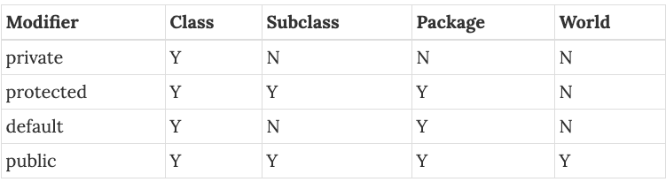

* **Nested classes:**

There are 2 types of nested classes: *static* and *non-static/inner.*

1. Static nested class should be created with the following format: new outer.nested()

outer and nested classes has access to each private static members:

class outer {  
 private static int *a* = 10;  
 public static void f() {  
 System.*out*.println(nested.*b*);  
 }  
  
 static class nested {  
 private static int *b* = 20;  
 public static void f() {  
 System.*out*.println(*a*);  
 }  
 }  
}

public static void main(String[] args) {  
 outer.*f*();  
 outer.nested.*f*();  
}

1. Inner class is connected to the object of outer class, for creating inner class:

outerObject.new Inner()

Inner class have direct access to all members of outer class

class outer {  
 private int a = 10;  
  
 class nested {  
 public void f() {  
 System.*out*.println(a);  
 }  
 }  
}

public static void main(String[] args) {  
 outer o = new outer();  
 outer.nested n = o.new nested();  
 n.f();  
}

* **String**:

class is immutable class. If we need to change a string it is better to user **StringBuilder** or **StringBuffer.** They have thesame logic, just StringBuffer is threadsafe, StringBuilder is not.

String str = “test”. The test will be stored in *String Pool,* which is a part of **Metaspace** memory (before Java 7 or 8 **Permanent memory**). In such way created a new “test” string will just refer to the same string:

String str1 = “test”; // creates a string In String pool  
 String str2 = “test”; // refer to the string from String pool  
 str1 == str2 // they refer to the same object

String str1 = new String(“test”); // create a string in heap

String str2 = new String(“test”); // create a string in heap

str1 != str2 // they refer to different objects

There is similar memory space like String pool for built in types (int, double, etc.)

* **Varargs: Variable-Length Arguments**

Varargs is just another form of array  
void f(int … v) { void f(int[] v) {

System.out.println(v.length); System.out.prinltn(v.length);

for (int x : v) { for (int x : v) {

} }

} }

f(1, 2, 3); f(new int[]{1, 2, 3});

there should be only 1 vararg argument of the function and it should be the last argument.

* **Interface:**

Interface vs abstract class: Interface doesn’t have a state.

Interface’s functions are by default public.

We can declare variables in interface, which by default will be static final. But it is preferable to use enum instead of declaring variables in interface.

interface Test {

void f();

int g(int n);

}

Class can partially implement an interface, but it will be abstract class.

Java 8 introduces **interface default methods and static methods.** Default methods introduced to be able to add a new function to an existing interface without breaking anything

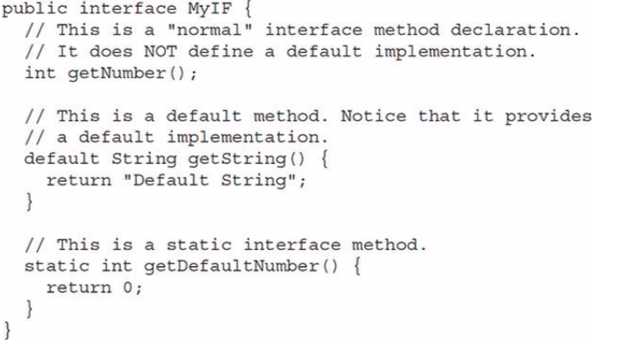

Java 9 introduces **private methods.** Private mathods can be called only by a default method or another private method, it can not be used outside of interface.

* **Lambda expression and Stream**

For creating a **lambda function/expression** it should be a type of interface (it is not just a function as in C++).

interface A {  
 void doAction(int a, int b);  
}

public static void main(String[] args) {  
 A f = (a, b) -> System.*out*.println(a + b);  
 f.doAction(1, 2);  
}

We can NOT create lambda function on class/abstract class

Interface containing only 1 abstract functions is called Functional Interface.

**Streams** never provide storage for the data, it simply iterates through data. As a general rule stream operations don’t modify the source. E.g. sorting a stream doesn’t change the source it returns a new stream on the sorted result.

Sampling of methods declared by Stream:

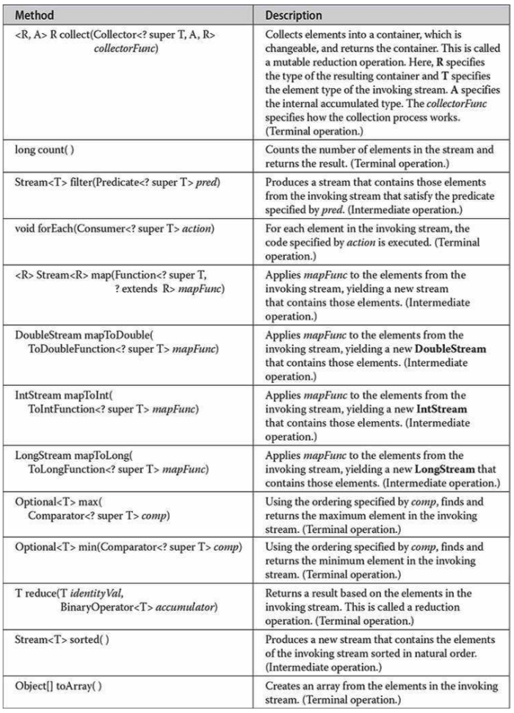

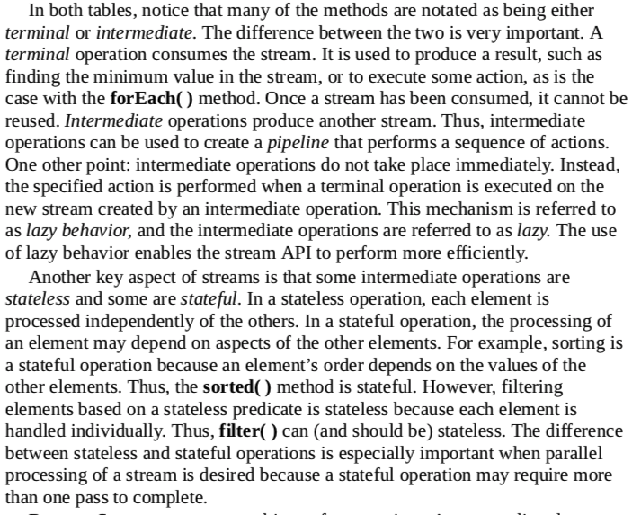

The intermediate function will not work if there is no terminate function:

list.stream().filter(v -> v > 0).map(v -> v * v);

This will **NOT** do anything.

For the first argument all intermediate function will work, when 2 argument, etc.

List<Integer> list = Arrays.*asList*(1, 2, 4, 5);  
list.stream().filter(v -> {  
 System.*out*.println("filter " + v);  
 return v > 0;  
}).map(v -> {  
 System.*out*.println("map " + v);  
 return v*v;  
}).collect(Collectors.*toList*());

The output will be:

filter 1

map 1

filter 2

map 2

filter 4

map 4

filter 5

map 5

Note: that the output is not filter1 filter2 … map1 map2…

If we should execute some code which is just iterating through all elements and doing 1 simple operation simple for/forEach will be **much faster** than stream.

**The advantage of stream:**

1. It has some uniformity and some logics can be replaced just by a simple function.
2. Very easy to switch to multithreading, just replacing stream() to **parallelStream()** or call **parallel()** on stream.

* **Exceptions:**

Java exception handling is managed via 5 keyword: try, catch, throw, throws (what exception a function may throw) and finally (the code will be executed in all cases).

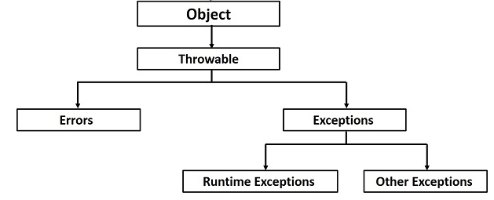

**Errors:** are exceptions in which cases we can not recover an application.

**e**.g. StackOverFlowError, OutOfMemoryError

**Runtime**: also called unchecked exceptions. Exceptions that can be thrown during normal operation of the JVM. There is no need to mark a function that may throw a runtiome exception

**Other exceptions**: checked exceptions. Declaring a new exception we must extend from Exceptions class. If a function may throw a checked exception we must mark it

void f() throws Exception

It is better to always catch exception as final, to be able to mark a function with original exception:

class LocalException extends Exception {  
}  
  
class A {  
 void f() throws LocalException {  
 try {  
 g();  
 } catch (final Exception e) {  
 e.printStackTrace();  
 throw e;  
 }  
 }  
   
 void g() throws LocalException {  
 throw new LocalException();  
 }  
}

in this case if catch is not marked as final it can be refer to other Exception and throws should be marked as Exception

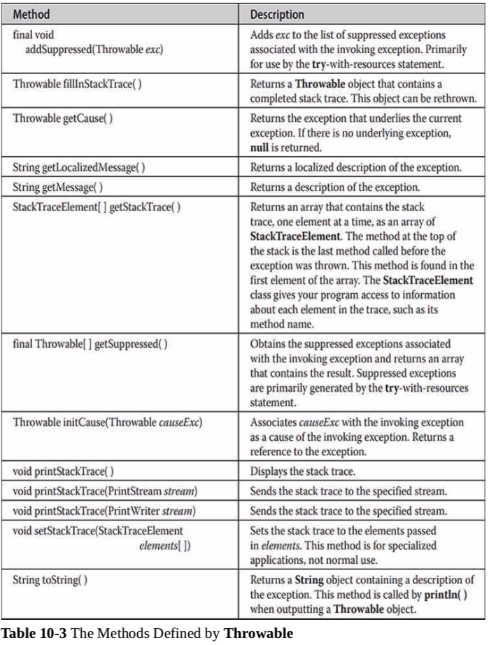

# **Try with resources:**

If we are working with file we should always close them.

Before Java 7 if there can be thrown an exception we should close a file in **finally** clause.

Java 7 introduces try with resources, which covers this case.

void f() {  
 try (Scanner scanner = new Scanner(new File("testRead.txt"));  
 PrintWriter writer = new PrintWriter(new File("testWrite.txt"))) {  
 while (scanner.hasNext()) {  
 writer.print(scanner.nextLine());  
 }  
 }  
}

In any case the file will be closed (in reverse order). To be able to use try-with-resource a class should extend from **AutoClosable**

* **Multithreading:**

There are 2 options to create thread in java:

1. extend from Thread class and override run function
2. implement Runnable interface and pass the object to Thread constructor.

The advantage of implementing Runnable is that we can still extend from other class.

Thread’s methods

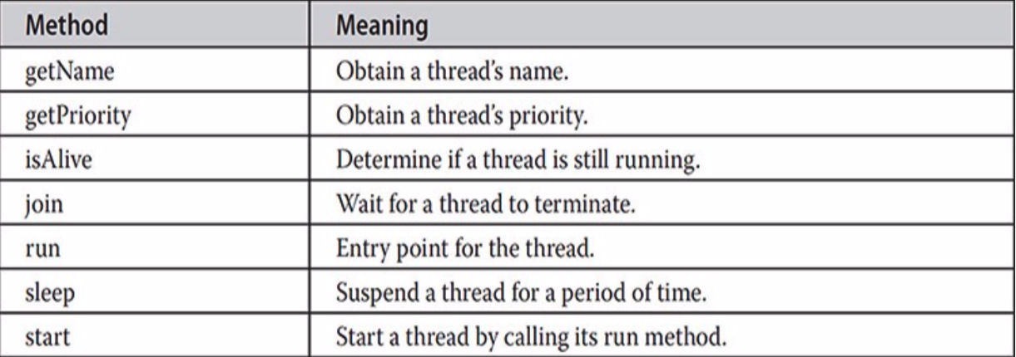

We are using **synchronized** to provide thread safety.

1. We can mark functions as synchronized
2. We can create synchronized block based on an object

Synchronized keyword is providing thread safety in scope of current object.  
e.g. if we have 2 synchronized blocks with a and b, it is not thread safe, several thread can be executed in 2 blocks at once.

Java Object class has 3 methods to provide interprocess communication (IPC): **wait(),** **notify()** and **notifyAll().** All 3 methods can be used only inside synchronized context.

There is possibility that in very rare cases the waiting thread could be awakened due to a **spurious wakeup.**

Thread also have state: getState()

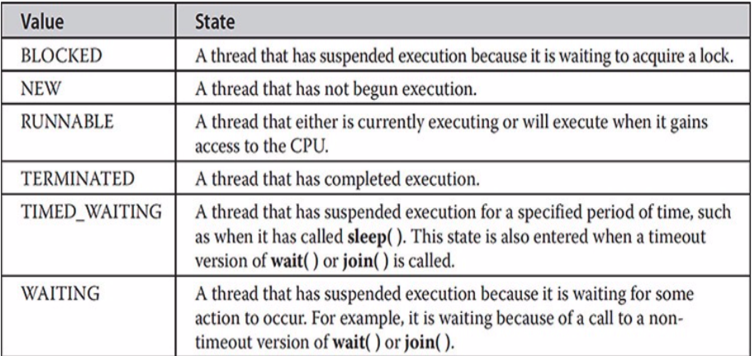

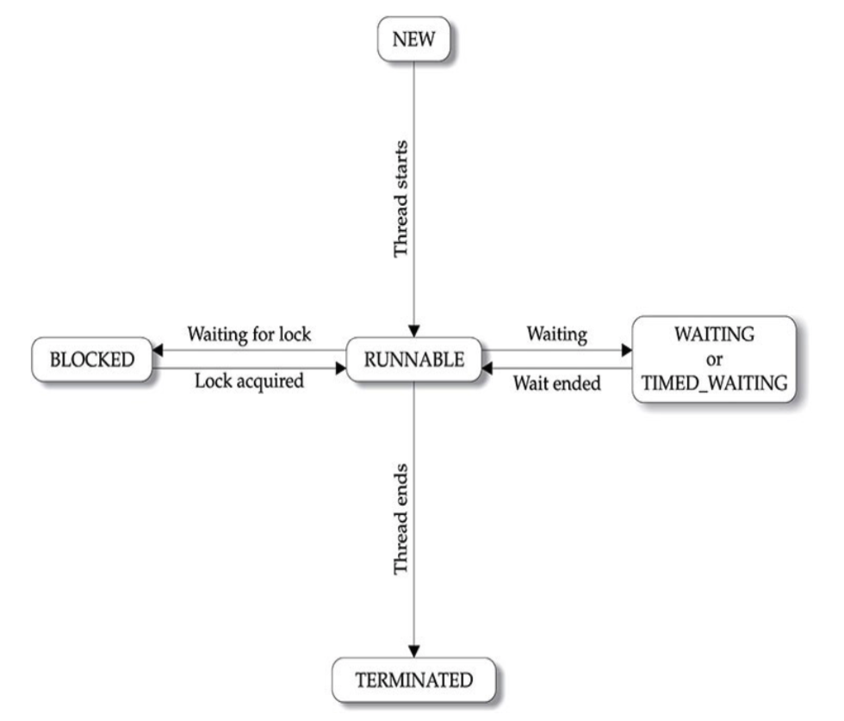

Implemenation of thread safe Buffer:

class Buffer<T> {  
 private int maxCount;  
 private Queue<T> queue = new LinkedList<>();  
  
 Buffer(int maxCount) {  
 this.maxCount = maxCount;  
 }  
  
 synchronized void push(T value) {  
 while (queue.size() >= maxCount) {  
 safeWait();  
 }  
 queue.add(value);  
 notify();  
 }  
  
 synchronized T pop() {  
 while (queue.isEmpty()) {  
 safeWait();  
 }  
 final T value = queue.poll();  
 notify();  
 return value;  
 }  
  
 private void safeWait() {  
 try {  
 wait();  
 } catch (final InterruptedException e) {  
 e.printStackTrace();  
 }  
 }  
}

Implementation of producer consumer <https://github.com/manukyanvruyr/ProducerConsumer>

<https://dzone.com/articles/the-evolution-of-producer-consumer-problem-in-java>

Each Thread has its own copy stack and caches. If they share some data between each other it is possible that one thread will change the value of variable, but will not update it on heap (will update it only in cache), so other thread will not now about the change.  
So even if the functions are synchronized the behavior will not be thread safe.

For this purpose there is **volatile** keyword, which insist a thread to not keep value in cache (use directly from heap) or keep the value up to date.

# **Double check singleton:**

1. We can implement singleton using enum

enum Singleton {  
 *INSTANCE*(4);  
  
 private int number;  
 private Singleton(int number) {  
 this.number = number;  
 }  
}

The initialization of enum instance is thread safe

1. Standard implementation:

class Singleton {  
 private static volatile Singleton *instance*;  
   
 public static Singleton getInstance() {  
 if (*instance* == null) {  
 synchronized (*instance*) {  
 if (*instance* == null) {  
 *instance* = new Singleton();  
 }  
 }  
 }  
 return *instance*;  
 }  
   
 private Singleton() {  
 }  
}

If we don’t declare instance as volatile, several threads can create an instance of Singleton without saving/reading it from heap.

Declaring volatile they will work direcly with the instance in heap (or always will be synced)

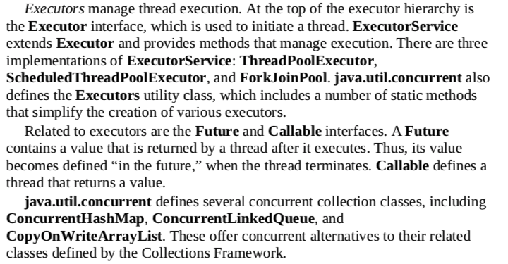

**Semaphore** controls the count of threads which can be executed. Semaphore stores a count member which will decrement when a thread starts executing and increment when the thread ends. If count > 0 then threads acquires a permit, if 0 the thread will be blocked until a permit can be acquired.

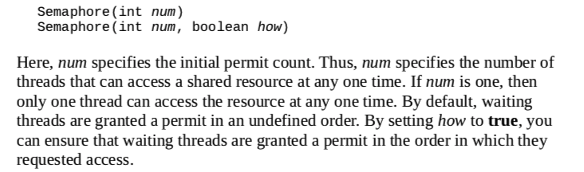

To get a permit we should use **acquire()** function, and we must use **release()** at the end.

* **Callable and Future**

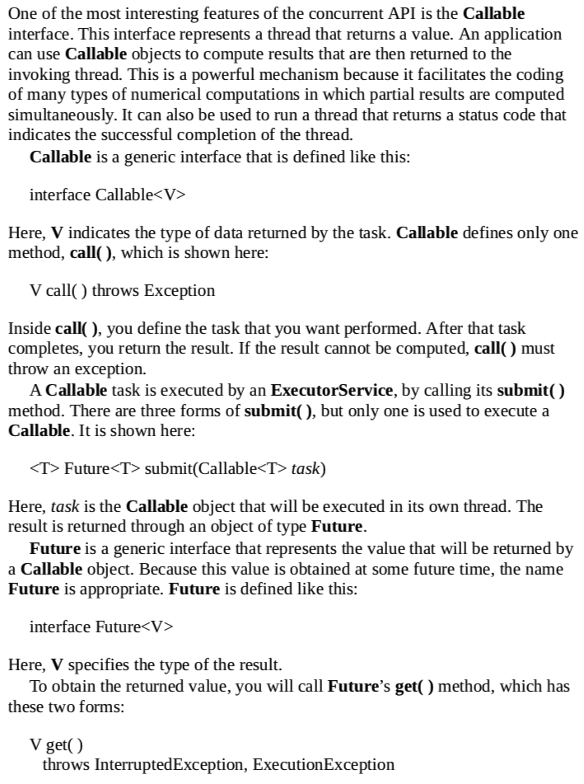

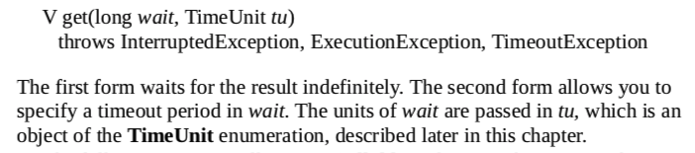

import java.util.concurrent.*;  
  
public class App  
{  
  
 public static void main(String[] args) throws InterruptedException, ExecutionException {  
 ExecutorService es = Executors.*newSingleThreadExecutor*();  
 Future<Integer> f = es.submit(new Sum(10));  
  
 System.*out*.println(f.get());  
  
 es.shutdown();  
 }  
  
 static class Sum implements Callable<Integer> {  
 int stop;  
  
 Sum(int stop) {  
 this.stop = stop;  
 }  
  
 @Override  
 public Integer call() {  
 int sum = 0;  
 for (int i = 1; i < stop; ++i) {  
 sum += i;  
 }  
 return sum;  
 }  
 }  
}

* **Fork/Join Framework**

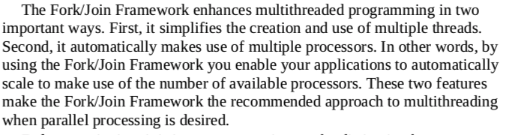

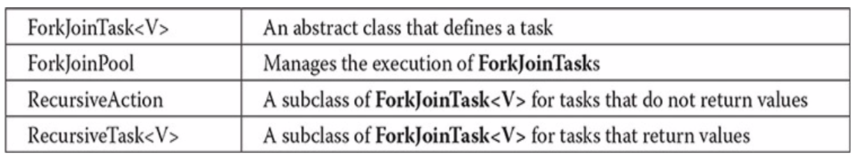

* **Transient:**

When an instance variable is declared as transient, its value will not persist when an object is stored (it will not be written to a file)

* **Native:**

Java provides native functions which is implemented in C/C++. The mechanism used to integrate native code with a Java program is called Java Native Interface (JNI)

javac -h . Main.java // to generate .h file

//create Main.cpp

g++ -I /Library/Java/JavaVirtualMachines/jdk1.8.0_172.jdk/Contents/Home/include/ -o libMain.dylib -dynamiclib Main.cpp

//if can't find jni_md.h

sudo cp /Library/Java/JavaVirtualMachines/jdk1.8.0_172.jdk/Contents/Home/include/darwin/jni_md.h /Library/Java/JavaVirtualMachines/jdk1.8.0_172.jdk/Contents/Home/include/

java -Djava.library.path=. Main

* **Annotations:**

It is a form of metadata that can be added to Java source code. All annotations are extend from Annotation class

@Retention(RetentionPolicy.*RUNTIME*)

@interface MyAnnotation {  
 String str();  
 int val();  
}

str() and val() functions are used as a variables:

@MyAnnotation(str = "example", val = 10)  
class A {

We can specify the retention policy of annotation, at what point they will be discarded.

Java.lang.annotation.RetentionPolicy:

1. **SOURCE** – is retained only in the source file and is discarded during compilation.
2. **CLASS** – is stored in .class file during compilation and is discarded during JVM runtime.
3. **RUNTIME** – is stored in .class file and available during JVM runtime

In the code we can access only to RUNTIME annotations using reflection.

* **Reflection:**

The first step to using reflection is to obtain a Class object

**final Class<?> getClass()**

Class supplies getMethod(), getMethods(), getField() and getConstructor() methods.



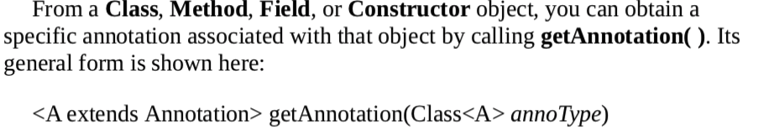

**Example 1**: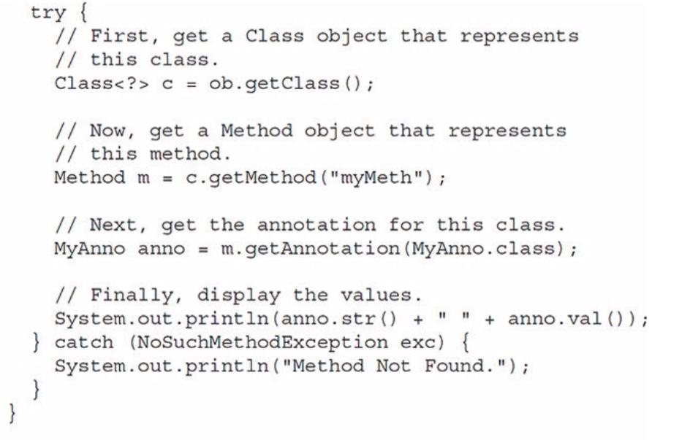

**Example 2:**

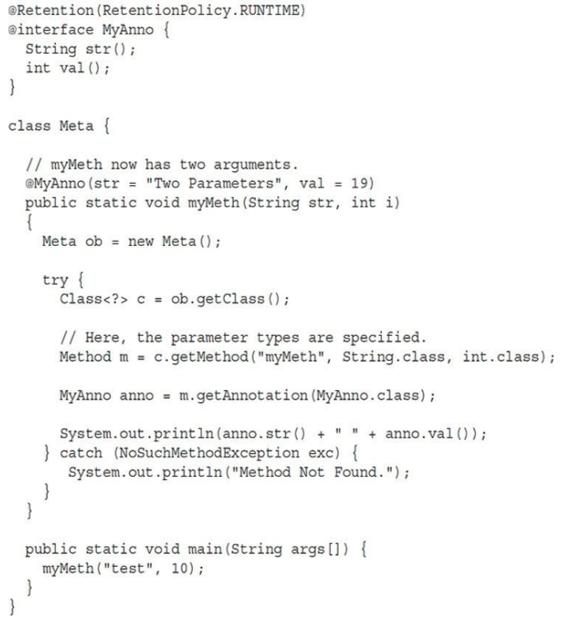

We can obtain all annotations by getAnnotations() function.

Class, Method, Filed, Constructor, Package classes are extend from AnnotatedElement class which provide getAnnotation() and getAnnotations() functions.

We can define default values for annotations members:

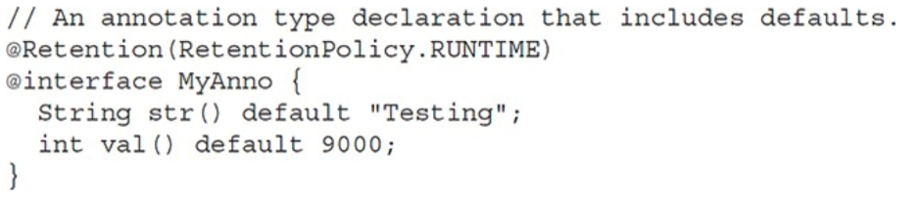

If annotation has only 1 function and its name is value(), we don’t need to specify the name:

@MyAnno(100);

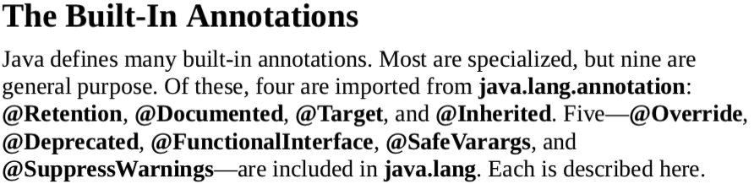

The **@Target** annotation specifies the types of items to which an annotation can be applied;

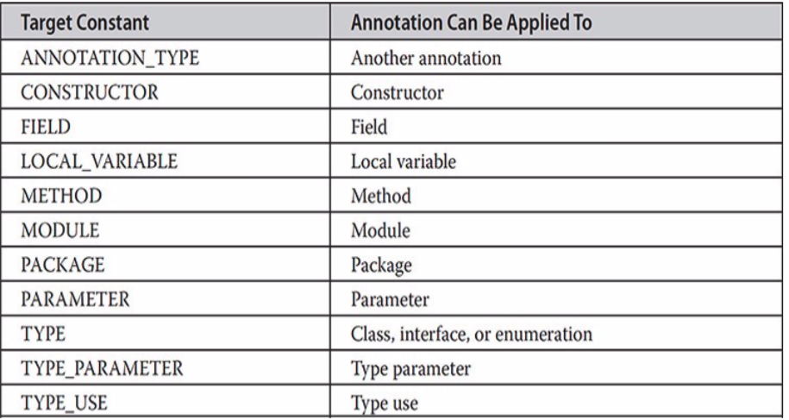

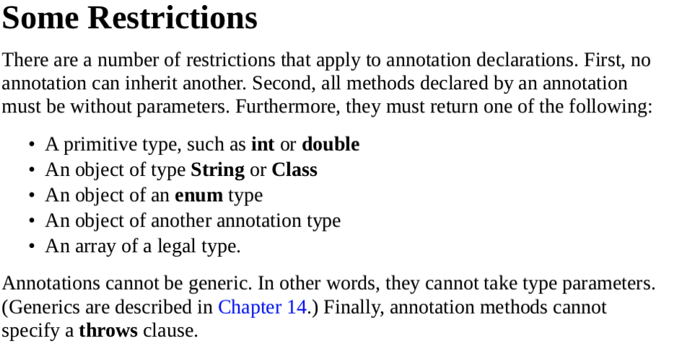

* **Memory management:**

Java (JVM) heap memory structure

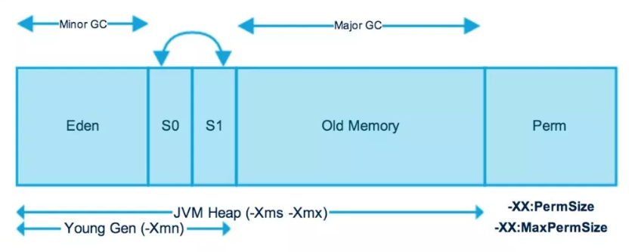

We have 2 types of Garbage Collectors: **Minor GC** and **Major GC**.

Minor GC works more frequently and moves newly created objects from

Eden-> Survivor 0 -> S1 -> Old Memory.

In Old generation Major GC is working and usually it is called when the memory is full.

**Permanent Generation (replaced by Metaspace sinve Java 8**): contains the application metadata by the JVM to describe the classes and methods used in the application, also static variables. They are garbage collected in a full garbage collection (when application is stopped).

Perm. Gen. is stored in Java heap due to which there can be OutOfMemoryError exception thrown (when we have many classes, static variables, etc.).

Metaspace is not part of the heap, it is stored in RAM (each Java program have their own heap). Metaspace by default auto increases its size, while Perm Gen always has fixed max size.

**Memory segments:**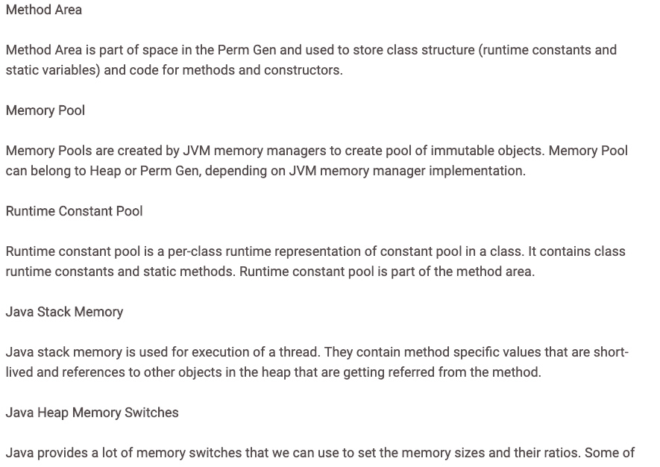

* **Garbage Collection:**

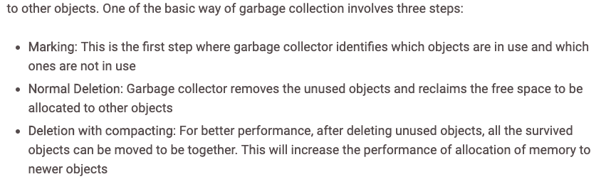

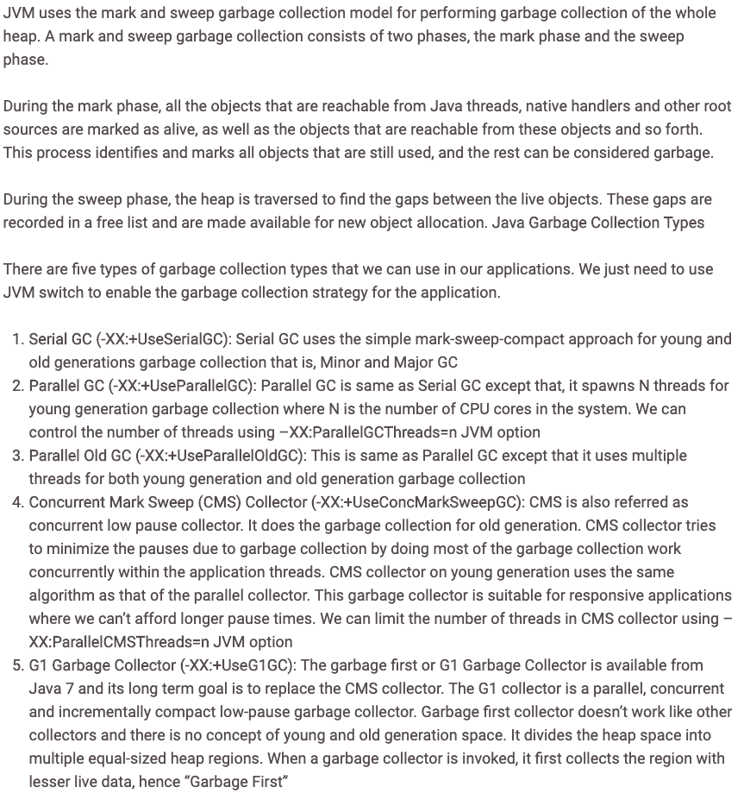

6. The Z Garbage Collector (ZGC) is a scalable low latency garbage collector. ZGC performs all expensive work concurrently, max stop time of application thread is 10 ms.

* **Reference types:**

There are 4 reference types in java:

1. **Strong reference:** It is the regular reference in Java. If there is a strong reference to an object, GC will not remove the object from the heap.
2. **SoftReference:** All objects which are referred only by soft references will be removed from the heap before JVM throws **OutOfMemoryError**.

SoftReference<String> s = new SoftReference<>("test");

1. **WeakReference:** this is the same as std::weak_ptr of C++.

All Objects which are referred only by weak references will be removed once GC is called.

WeakReference<String> s = new WeakReference<>("test");

1. **PhantomReference:** they are used to know when the object is destructed (instead of using finalize() method, which is deprecated since Java 9). PhantomRefernce is used with ReferenceQueue.

* **Generics:**

Java Generics differs from C++ objects. Java Generics just stores all values as Object type, and during function calls it is doing appropriate castings. E.g.

class A<T> {  
 private T ob;  
   
 A(T ob) {  
 this.ob = ob;  
 }  
   
 T get() {  
 return ob;  
 }  
}

for A<Integer> it is the same as:

class A {  
 private Object ob;  
  
 A(Integer ob) {  
 this.ob = (Object) ob;  
 }  
  
 Integer get() {  
 return (Integer) ob;  
 }  
}

We can specify the scope of type:

1. <T extends superclass> the upper limit of T is superclass. So it’s type can be superclass or its child. T will be cast to superclass (not Object). We can specify all parent class and interfaces. The first one should be class.

<T extends superclass & interface1 & interfac2>

1. <T super subclass> the lower limit of T is subclass.

class A<T> {  
 private T ob;  
  
 public <I> void f(A<I> a) {  
 System.*out*.println(this.getClass().getName());  
 System.*out*.println(a.getClass().getName());  
 }  
}

We can replace such generic function with wildcard:

class A<T> {  
 private T ob;  
  
 public void f(A<?> a) {  
 System.*out*.println(this.getClass().getName());  
 System.*out*.println(a.getClass().getName());  
 }  
}

Such wildcard can be used as return type:  
 Class<?> getClass();

If we want to use instanceof with generics we **must** use wildcard

If (a instanceof A<?>)

If (a instanceof A<Integer>) // error, at runtime there is no type

We can create raw type of class, for using old codes with generics:

A a = new A(10);

But in this case it is not secure, we should do all casts ourselves which can lead to runtime errors. So it is not recommended to use raw types.

**Restrictions:**

1. The generic type parameter can’t be instantiated:

T t = new T() // error

1. Can’t create arrays:

A<Integer> a[] = new A<Integer>[10] // error

A<?> a[] = new A<?>[10] // ok

1. Can’t extend from Throwable

* **Clone()**

Object class contains clone() function which are doing shallow copy.  
The clone function is declared protected, so we can use it inside the class, but calling clone() function will throw **CloneNotSupportedException**.

1. We should or override clone function and can make it public
2. Implements **Cloneable** interface which will allow to call clone function of Object class (shallow copy)

* **Comparable**

Objects of classes that implement Comparable can be ordered.

interface Comparable<T> {

int compareTo(T o);

}

We can insert elements into TreeSet by providing object of **Comparator** interface

* **Iterable:**

Iterable must be implemented by any class whose objects will be used in for-each loop (for (int x : v) ).

Collection interface extends from Iterable.

The interface has

1. Iterator<T> iterator() abstract function
2. default void forEach(Consumer<? super T> action) {  
    Objects.*requireNonNull*(action);  
    for (T t : this) {  
    action.accept(t);  
    }  
   }
3. default Spliterator<T> spliterator() {  
    return Spliterators.*spliteratorUnknownSize*(iterator(), 0);  
   }

* **Collections**

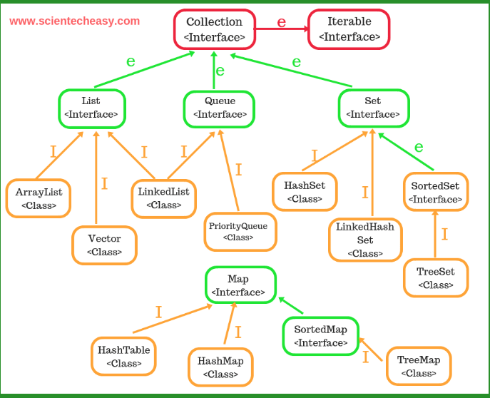

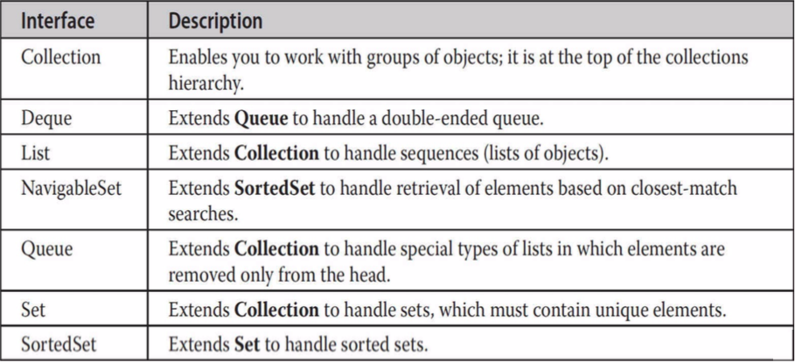

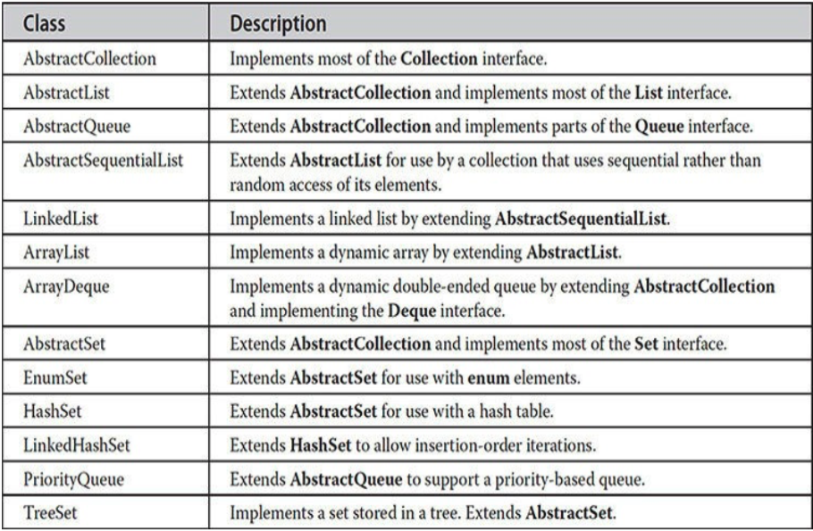

Collection interface extends from Iterable interface which allows to use for-each with collections.

Map doesn’t extend from Collection and Iterable. So we can’t use it in for-each and can’t get an iterator. If we want use for-each with maps we can use entrySet() function which returns set of Map.Entry(pair).

TreeSet and HashSet implemented based on the TreeMap/HashMap (but actually it should be vice versa).

SplitIterator introduced in Java 8. It is the same as iterator just can be used in multithreading.

Collection which provide random access should implement RandomAccess interface, which is just a marker (empty interface). In Collections algorithms many algorithms works differently if the class is instance of RandomAccess.

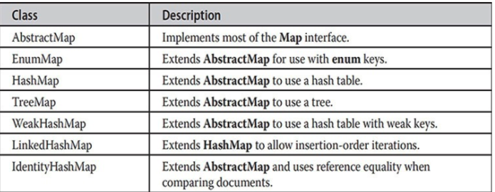

* 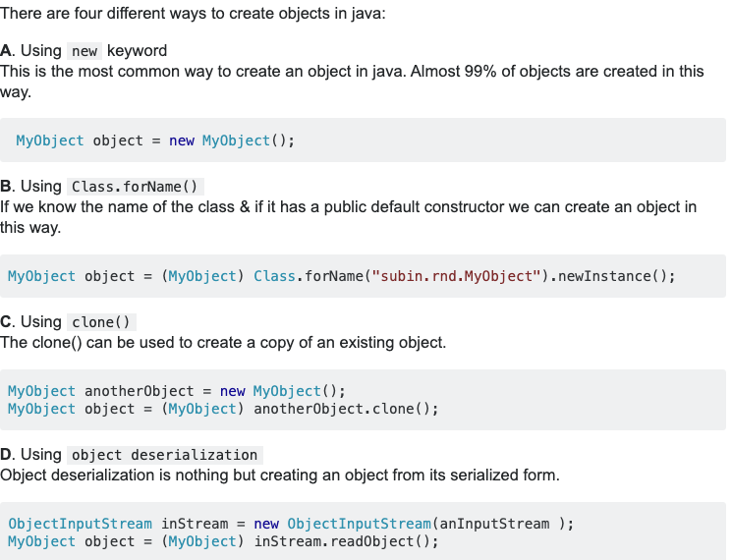
* **Timer and TimerTask:**

To schedule a task for execution at future.

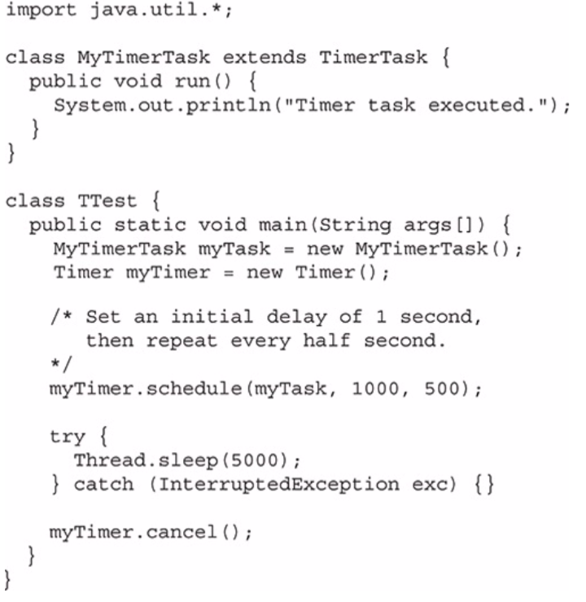

* **Serialization**

Remote Method Invocation (RMI) allows a Java object on one machine to invoke a method of a Java object on a different machine.  
Serializing an object which have references to other objects, will also serialize the referenced objects recursively.

To be able to serialize an object it should implement **Serializable** interface. Static variables and transient variables will not be saved.

<https://www.geeksforgeeks.org/serialization-in-java/>

class B {

// class B implements Serializable {  
 String s;  
 B(String s) {  
 this.s = s;  
 }  
  
}  
  
class C implements Serializable {  
 B b;  
 C(B b) {  
 this.b = b;  
 }  
}  
  
public class App  
{  
 public static void main(String[] args) {  
 try {  
 FileOutputStream file = new FileOutputStream("test");  
 ObjectOutputStream out = new ObjectOutputStream(file);  
 out.writeObject(new C(new B("str")));  
  
 FileInputStream f = new FileInputStream("test");  
 ObjectInputStream in = new ObjectInputStream(f);  
  
 C c = (C)in.readObject();  
 System.*out*.println(c.b.s);  
  
 } catch (IOException e) {  
 }  
 }  
}

In this case the deserialized will be empty as class B doesn’t implement Serializable. To be able to serialize b object of class A, class B should implement Serializable.

* **Netwroking**

InetAddress class is used to encapsulate the IP address and the name for that address.

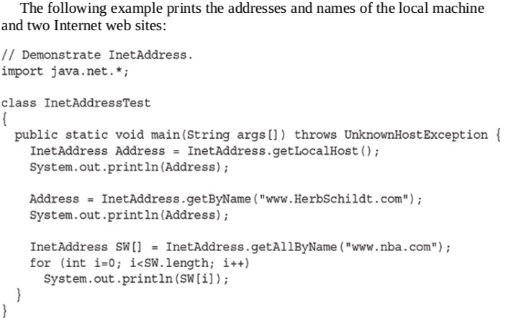

Port number can be from 0 to 65535 **ServerSocket** class is designed to be a listener, which waits for clients to connect before doing anything.

**Socket** class is for client. They use **TCP**.

You can gain access to the input and output streams associated with Socket by use if **getInputStream()** and **getOuputStream()** functions.

Server/Client simple example using sockets - <https://github.com/manukyanvruyr/ServerClient>

Server/Client multithreaded example - <https://www.geeksforgeeks.org/introducing-threads-socket-programming-java/>

* **Remote Method Invocation (RMI)**

RMI allows a Java object that executes on one machine to invoke a method of Java object that executes on another machine. It allows to build distributed application.

* **LDAP**

AD is a hierarchical structure that stores information about objects on the network.

Lightweight Directory Access Protocol(LDAP) allows to communicate with Active Directory(AD). It is based on TCP/IP.

Sources about LDAP - <https://tools.ietf.org/html/rfc4511> <https://www.youtube.com/channel/UChJ6OvOQPC-58OBHcdzELxA>

Example of LDAP.

First of all we should create AD. Install Apache Directory Studio and create some users (see in youtube link).

import javax.naming.Context;  
import javax.naming.NamingEnumeration;  
import javax.naming.directory.*;  
import java.util.Hashtable;  
import java.util.Random;  
  
public class App {  
 static DirContext *context*;  
 static Random *random* = new Random();  
  
 public static void main(String[] args) throws Exception {  
  
 Hashtable<String, String> environment = new Hashtable<String, String>();  
  
 // which factory class use to create an initial context  
 environment.put(Context.*INITIAL_CONTEXT_FACTORY*, "com.sun.jndi.ldap.LdapCtxFactory");  
 // host and port  
 environment.put(Context.*PROVIDER_URL*, "ldap://localhost:10389");  
 // authentication type there are 3 types none, simple and SASL  
 environment.put(Context.*SECURITY_AUTHENTICATION*, "simple");  
  
 // login dn (distinguish name)  
 environment.put(Context.*SECURITY_PRINCIPAL*, "uid=admin,ou=system");  
 // password  
 environment.put(Context.*SECURITY_CREDENTIALS*, "secret");  
   
 *context* = new InitialDirContext(environment);  
 System.*out*.println("Connected..");  
 System.*out*.println(*context*.getEnvironment());  
  
 *printUsers*();  
 *printGroups*();  
  
 //createUser();

// need testing  
 *checkPassword*(1, "1234");  
 *checkPassword*(1, "12345");  
 }  
  
 static void printUsers() throws Exception {  
 System.*out*.println();  
 System.*out*.println("/////// print users");  
 // what to search  
 String searchBase = "ou=users, o=Company";  
 // which type of object to get  
 //String searchFilter = "objectClass=inetOrgPerson";  
 String searchFilter = "objectClass=person";  
 //String searchFilter = "objectClass=room";  
  
 String[] attributes = {"cn", "sn", "employeeNumber", "objectClass", "uid"};

SearchControls ctls = new SearchControls();  
 ctls.setReturningAttributes(attributes);  
 ctls.setSearchScope(SearchControls.*SUBTREE_SCOPE*);  
  
 NamingEnumeration names = *context*.search(searchBase, searchFilter, ctls);  
 while (names.hasMore()) {  
 SearchResult result = (SearchResult) names.next();  
 Attributes attrs = result.getAttributes();  
 System.*out*.println("attr: " + attrs);  
 }  
 }  
  
  
 static void printGroups() throws Exception {  
 System.*out*.println();  
 System.*out*.println("/////// print groups");  
  
 // Search groups  
 String searchBase = "ou=Groups,o=Company";  
 String searchFilter = "objectClass=groupOfUniqueNames";  
 String[] attribute = {"cn"};  
  
 SearchControls ctls = new SearchControls();  
 ctls.setReturningAttributes(attribute);  
 ctls.setSearchScope(SearchControls.*SUBTREE_SCOPE*);  
  
 NamingEnumeration names = *context*.search(searchBase, searchFilter, ctls);  
 while (names.hasMore()) {  
 SearchResult result = (SearchResult)names.next();  
 System.*out*.println("name: " + result.getName());  
 Attributes attrs = result.getAttributes();  
 System.*out*.println("attr: " + attrs);  
 }  
 }  
  
 static void checkPassword(int userId, String passowrd) throws Exception {  
  
 System.*out*.println();  
 System.*out*.println("/////// check users");  
 // what to search  
 String searchBase = "ou=users, o=Company";  
 // which type of object to get  
 String searchFilter = "(&(objectClass=inetOrgPerson)(employeeNumber=" + userId +  
 ")(userPassword=" + passowrd + "))";  
  
 SearchControls ctls = new SearchControls();  
 ctls.setSearchScope(SearchControls.*SUBTREE_SCOPE*);  
  
 NamingEnumeration names = *context*.search(searchBase, searchFilter, ctls);  
  
 System.*out*.print("User with id = " + userId + ", password = " + passowrd + " is ");  
 if (names.hasMore()) {  
 System.*out*.println("found");  
 } else {  
 System.*out*.println("not found");  
 }  
 }  
  
 static void createUser() throws Exception {  
 System.*out*.println();  
 System.*out*.println("/////// create user");  
  
 Attributes attributes = new BasicAttributes();  
 attributes.put("objectClass", "inetOrgPerson");  
 attributes.put("sn", "surname" + *random*.nextInt());  
 attributes.put("cn", "commonName" + *random*.nextInt());  
  
 *context*.createSubcontext("employeeNumber=" + *random*.nextInt() +  
 ",ou=users, o=Company", attributes);  
 System.*out*.println("Created new user:");  
 System.*out*.println(attributes);  
 }  
}

* **Java Bean**

